Environmental Controls – Temperature@Alert
Originator: | Sender De La Roca |  | Effective Date: | September 26, 2024
Manager Approval: | Sender De La Roca |  | Original Date: | September 26, 2024
 |  |  | Revision Date: | September 26, 2024
PURPOSE
The purpose of this procedure is to ensure the accurate monitoring and management of environmental conditions using TEMPERATURE@LERT Temperature and Humidity Sensors. These sensors are designed to measure and report temperature and humidity levels in real-time, providing critical data to maintain optimal conditions for various applications. This procedure outlines the steps for setting up, configuring, and maintaining the sensors to ensure reliable performance and timely alerts in case of deviations from specified thresholds. By following this procedure, users can effectively utilize the TEMPERATURE@LERT system to safeguard sensitive environments and ensure compliance with regulatory requirements.

Contents
Environmental Controls – Temperature@Alert 1
TEMPERATURE@LERT TEMPERATURE AND HUMIDITY SENSORS 2
Controller IP Address and Sensor Locations: 2
DATA CENTER FLOOR PLAN OF CONTROLLER AND SENSOR LOCATIONS 4
Checking the Temperature and Humidity Status: 5
Recording temperatures and keeping logs: 7

PROCEDURES

Environmental Controls – Temperature@Alert
The data center is designed to provide optimal operational conditions for servers, networking, and telecommunication equipment. It is equipped with dedicated Computer Room Air Conditioning (CRAC) systems that provide precise cooling to maintain the integrity and performance of all hardware components.
To safeguard against environmental fluctuations, the data center is outfitted with advanced temperature and fire monitoring systems. These systems are programmed to alert administrators immediately if the environmental conditions deviate from the established parameters. (See table “temperature and humidity settings for the sensors“ in this procedure.)
The climate control settings are calibrated to maintain a consistent temperature range between 65 to 68 degrees Fahrenheit and the recommended relative humidity levels for data centers ranges of 45% to 55%. In the event of any changes in these conditions from the set ranges, data center staff are promptly notified via email notifications and text messages, ensuring swift response and mitigation.

TEMPERATURE@LERT TEMPERATURE AND HUMIDITY SENSORS

Controller IP Address and Sensor Locations:
156.3.202.227 – Tape Library/Network Room Controller (C1)
Sensor 1 – Tape Library (C1S1)
Sensor 2 – Paper Storage Area (C1S2)
Sensor 3 – Network Room (C1S3)
156.3.202.228 – 6160 Room (EC169)/Warrant Room Controller (C2)
Sensor 1 – 6160 Room_EC169 (C2S1)
Sensor 2 – 6160 Room_EC169 (C2S2)
Sensor 3 – Warrant Room (C2S3)
156.3.202.229 – Computer Room (Ops Area)/UPS Room Controller (C3)
Sensor 1 – Computer Room (C3S1)
Sensor 2 – Computer Room (C3S2)
Sensor 3 – UPS Room (C3S3)
156.3.202.230 – Server Room Controller (C4)
Sensor 1 – Server Room (C4S1)
Sensor 2 – Server Room (C4S2)
Sensor 3 – Server Room (C4S3)

DATA CENTER FLOOR PLAN OF CONTROLLER AND SENSOR LOCATIONS
Legend: C1/C2/C3/C4 – Controllers
 | C1 | C2 | C3 | C4
Sensor | Tape Library/Paper Storage/Network Room Controller 156.3.202.227 | 6160/Warrant Room Controller 156.3.202.228 | Computer/UPS Room Controller 156.3.202.229 | Server Room Controller 156.3.202.230
S1 | Tape Library | 6160 Room | Computer Room (OPS Area) | Server Room
S2 | Paper Storage | 6160 Room | Computer Room (OPS Area) | Server Room
S3 | Network Room | Warrant Room | UPS Room | Server Room

Checking the Temperature and Humidity Status:
To check the temperature and humidity status, login to a web browser (Internet Explorer or Firefox).
Type the IP address of the controller on the browser’s address bar: (Ex. http://156.3.202.230)
Log in to the following IP Addresses to check on each of the equipment:
156.3.202.227 , 156.3.202.228, 156.3.202.229, 156.3.202.230
You may want to save these addresses as favorites on your web browser for easier access.
Example for 156.3.202.227
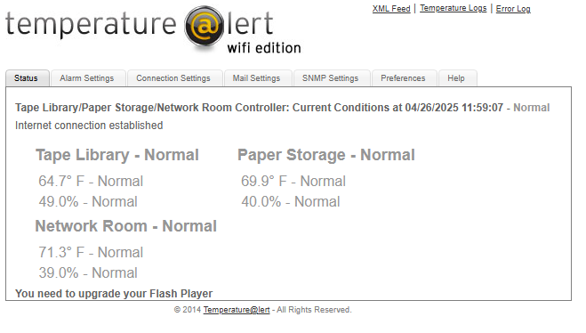
This will show the current Temperature and Humidity conditions being monitored by each sensor. The equipment logs the temperature and humidity every 5 minutes.
Note at the top right hand of the page, there is a link to the Temperature Logs. This will give you a text form of the log in case it is needed.

The table below shows the temperature and humidity settings for the sensors:
Sensor | Min-Max Normal Temperature Setting (degrees Fahrenheit) | Min-Max Humidity Setting (%)
Tape Library | 65-75 | 30-60
Paper Storage Area | 65-75 | 35-45
Network Room | 65-75 | 30-60
6160 Room (2) | 65-75 | 30-60
Warrant Room | 65-77 | 35-45
Computer Room (2) | 65-75 | 30-60
UPS Room | 65-78 | 30-60
Server Room (3) | 65-75 | 30-60

ALARMS
Alarms from the Temperature@lert Sensors will come from lacoe.temperaturealert@gmail.com and will send email to TSComputerOperations@lacoe.edu.
The alarm message will be received every 30mins when the Temperature/Humidity Settings have been exceeded and until the conditions have been returned to normal. Another message will be received when the readings return to normal.
Please proceed with current procedures as far as handling environmental issues in the computer room.

Recording temperatures and keeping logs:

On the shift turnover in section VIII, record the temperatures as required in the log. If there are issues with the CRAC units where they are down or temperature alerts such as the cooling tower down, record temperatures every hour.
VIII. TEMPERATURE AND HUMIDITY STATUS
TIME | SILO  ROOM | Network Room  ROOM | 6160  ROOM | WARRANT  ROOM | COMPUTER  ROOM | UPS  ROOM | SERVER  ROOM
 | http://156.3.202.227 | http://156.3.202.227 | http://156.3.202.228 | http://156.3.202.228 | http://156.3.202.229 | http://156.3.202.229 | http://156.3.202.230
10:00 | 64.7°/49% | 71.3°/38% | 67.9°/43% | 65.5°/45% | 70.3°/39% | 64.7°/53% | 69.5°/38%
14:00 | 64.7°/48% | 71.0°/38% | 67.9°/43% | 65.5°/45% | 70.1°/38% | 64.7°/52% | 69.7°/38%
18:00
22:00
02:00
06:00

